
Kunal Sharma is a serial entrepreneur, angel investor and design-tech visionary transforming the commercial real estate and interior design ecosystem. An alumnus of IIT Bombay, he founded Flipspaces with a vision to revolutionise commercial interior design and execution through technology, innovation and a more predictable approach to building workspaces.
Under his leadership, Flipspaces has developed a technology-driven model that combines design, virtual reality, software and end-to-end execution to simplify the commercial interior design and build process. The company has expanded its presence across India, the United States and the Middle East, helping businesses create functional, high-performance workspaces through a more integrated and transparent approach.
Before founding Flipspaces, Kunal co-founded Mexus Education, an education technology venture that reached over a million students across eight countries. His entrepreneurial journey reflects a strong ability to identify industry inefficiencies, leverage technology to solve real-world problems and build businesses with global ambitions.
Beyond business, Kunal is passionate about innovation, entrepreneurship and supporting emerging founders. His experience across technology, design, business strategy and global expansion brings a valuable perspective to entrepreneurs looking to scale their ventures and build sustainable businesses.

Link - https://www.youtube.com/watch?v=DtJu-RkgQXU

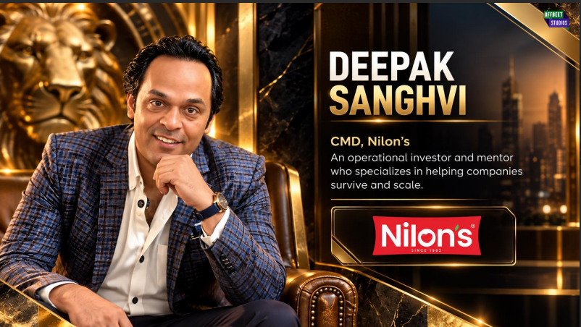

Dipak Sanghavi is a seasoned entrepreneur and business leader who has played a pivotal role in transforming Nilon’s into one of India’s recognised processed food brands. A Polymer Engineering graduate with a leadership programme from IIM Ahmedabad, he took charge of the family business at the age of 24 and brought a strong focus on strategic growth, consumer preferences and operational excellence.
Under his leadership, Nilon’s evolved from a pickle-focused business into a diversified food solutions company, expanding its presence across multiple product categories and markets. His journey reflects the ability to combine traditional Indian food preferences with modern manufacturing, distribution and brand-building strategies.
With deep experience in FMCG, product innovation, distribution networks and business expansion, Dipak brings a practical understanding of what it takes to build a consumer brand that can scale nationally while remaining relevant to everyday Indian households.
Link - https://www.youtube.com/watch?v=rQ6hrGgeb7s
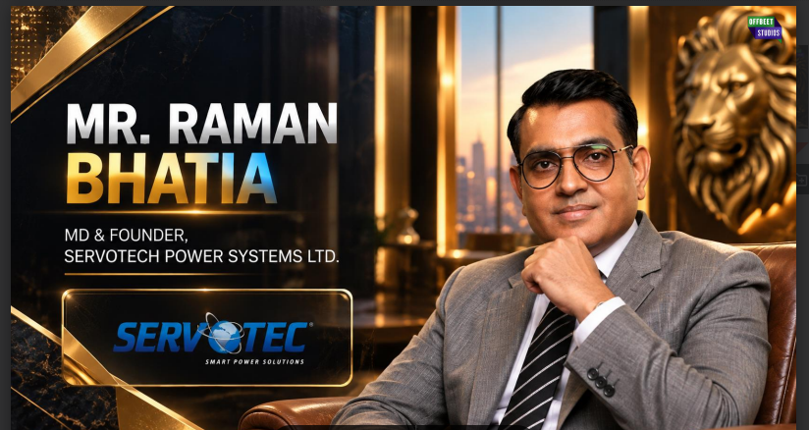
Raman Bhatia is an entrepreneur and clean-energy industry leader driving innovation across renewable energy, solar power and electric vehicle charging infrastructure. With more than two decades of business experience, he has built Servotech Renewable Power System Limited into a publicly listed company serving India's evolving energy and mobility needs.
His entrepreneurial journey began in the family’s cable business before he ventured into power solutions and manufacturing. Recognising the growing potential of solar energy and electric mobility, he steered Servotech towards a broader portfolio of renewable energy products, power electronics and EV charging solutions.
Known for his perseverance, strategic vision and ability to identify emerging market opportunities, Raman combines a manufacturing-led business approach with a long-term commitment to sustainable technology. His experience offers valuable insights into building technology-driven businesses in capital-intensive and rapidly evolving industries.
Link - https://www.youtube.com/watch?v=9LG33pgsOMU
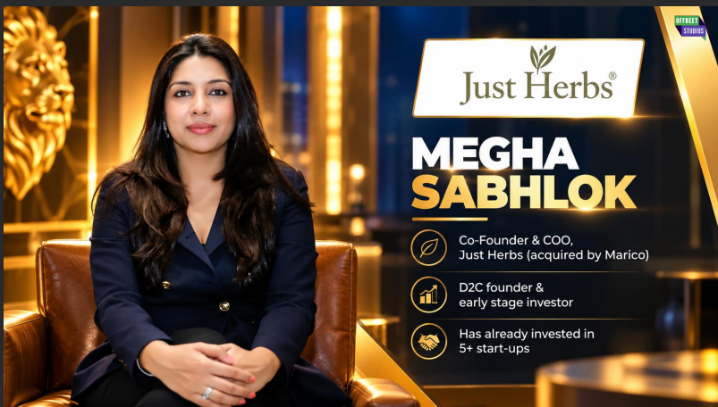
Megha Sabhlok is being featured in connection with Just Herbs, a brand operating in India's beauty and personal-care market. Just Herbs is associated with Ayurveda-inspired formulations and a modern approach to skincare, haircare and beauty products.
The brand operates at the intersection of traditional Indian wellness practices and contemporary consumer expectations, where product efficacy, ingredient transparency, customer trust and brand differentiation are central to long-term growth.
A final profile for Megha should highlight her specific contribution to the brand's leadership, strategy, marketing or business development, once her current role and professional background have been confirmed. This will ensure the published profile accurately reflects her individual achievements rather than attributing the company's overall journey to her without verification.

